System Information and Resource Monitoring
Learn to monitor system resources and gather system information. Master tools for checking CPU load, memory usage, disk space, and system identity. Learn to use the watch command for continuous monitoring.
Uname -a: (Unix Name - All) to know the kernel version.
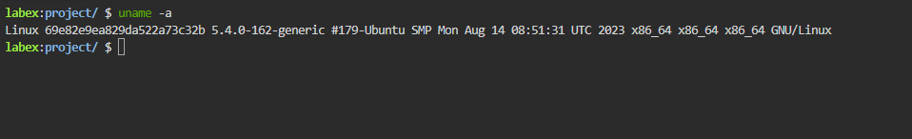

Check OS Version (/etc/os-release)
What logical "Flavor" (Distribution) is this? (e.g., Ubuntu, CentOS). Read /etc/os-release
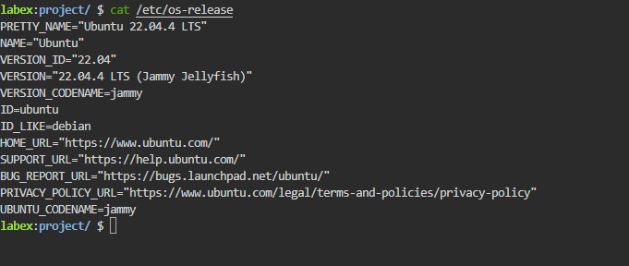
Check Uptime (uptime)
How long has the computer been on?
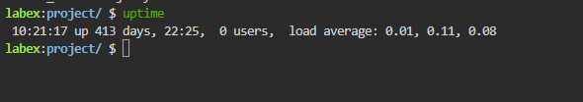

Memory and Swap Usage
Check Memory (free)
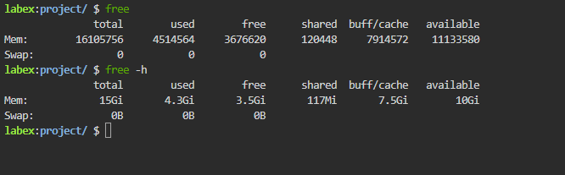

Understand Available Memory: Low "free" memory is not automatically bad, because Linux intentionally uses spare memory for caching to improve performance.
Rule: Worry if available is low, not free.
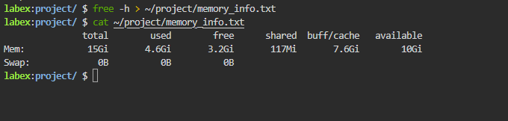
Disk Space Usage
Filesystems running near full capacity can cause strange behavior, failed writes, logging problems, and service outages. Disk monitoring is therefore one of the most practical system health checks.
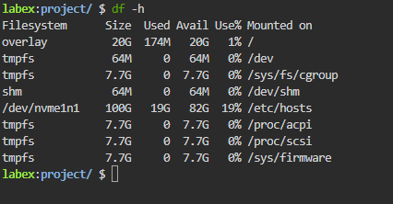
Check Root Partition
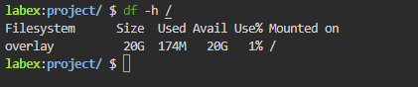
Check Directory Size (du -sh)
df and du complement each other: df reports usage from the filesystem's perspective, while du measures the size of directories and files inside it.

Analyze Directory Contents (du -ah)
We found a heavy box. Open it to find the culprit.
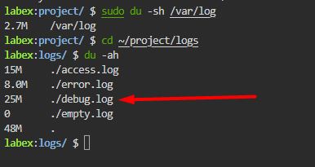
This is the basic workflow for storage troubleshooting: identify the full filesystem, narrow down the large directory, then inspect the large files inside it.

CPU Load Averages
View Load Averages (uptime) Check the traffic report with uptime
Understand Load Trends Why three numbers? They are the average load over time:
1 minute (Traffic right now).
5 minutes (Traffic 5 mins ago).
15 minutes (Traffic 15 mins ago).
Reading the Trend:
1 min < 15 min: Traffic is clearing up.
1 min > 15 min: Traffic is building up (Jam starting).
Trend matters because a single instant can be misleading. A load spike that is already falling is a very different story from one that is still rising.


Count CPU Cores (nproc)
Is Load 1.0 bad? It depends on your lanes (Cores).
1 Core: Load 1.0 is 100% full.
4 Cores: Load 1.0 is 25% full.
That is why core count changes the interpretation completely. The same load value can be harmless on a multi-core machine and severe on a single-core one.
Check your lanes with nproc:


